Get api: to get the result on basis of id.

Delete api: Delete on basis of id.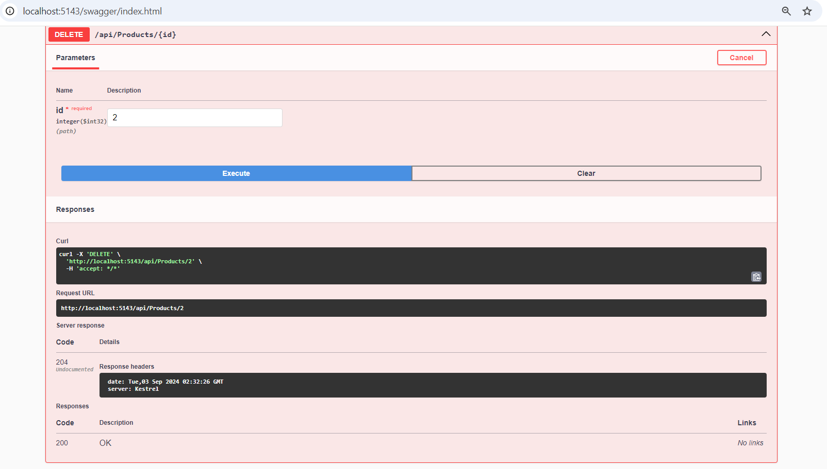

Put api: To update the data.

unit tests for the API endpoints